MEDIA RELEASE
Interned
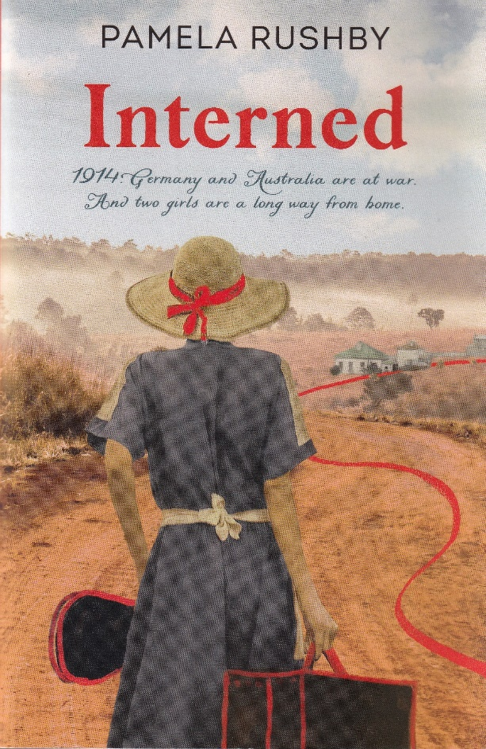

Australia jailed 7000 ‘enemy aliens’ of German origin during World War 1. Most of these were men. But 84 were children.
It’s 1914. The world is on the brink of war. Gretta, daughter of a German businessman, lives a privileged life in Singapore. Tilly, daughter of a German-born baker, lives a modest life in Brisbane. Two very different lives. But the girls will spend the next four years together, in Australia. In an internment camp. Jailed.
A middle-grade historical novel by multi-award winning author Pamela Rushby
Based on true events, Interned is a moving, well-researched and evocative historical fiction novel that highlights an often forgotten moment in Australian history.
Pam would be delighted to talk about prejudice, propaganda, the effects of long-term incarceration and changing attitudes in society – and the book, of course!
Published by Walker Books, 2022 ISBN 9781760653019
For interview or further information: Pamela Rushby
P.Rushby@internode.on.net 0418778058 www.pamelarushby.com

